Quantification of shark collective behaviour

*Image analysis toolbox*

We developed a semi-automatized technique (toolbox) in Matlab (Mathworks, Natick, MA, U.S.A) to detect and position individual sharks on aerial frames. This toolbox was primarily designed to allow quantifying shoaling tendency of aggregated blacktip reef sharks in the two studied habitats. In particular, this approach was employed to estimate the relative size of sharks (in pixels), between-individual distances and level of alignment of shoaling individuals. The procedure encompassed two successive steps, with first a “point-and-click” labeling of individual sharks on a given frame, followed by post-processing analyses.

* 1. *Shark labeling*

Analyzing still images collected from mobile observatory devices (e.g., drones) implies that the whole scene moves from one frame to another, making application of common image processing techniques, such as background removal or thresholding, not suitable. Consequently, it was not possible to fully automatize, in our case, shark detection on a given frame and the intervention of an observer was necessary to fulfil the shark labeling procedure.

Shark labeling process started by displaying a sample aerial image to be scrutinized (Figure 1). In order to alleviate labeling all sharks sighted in a single frame, each image was cropped and adjusted to smaller areas of interest containing sharks. Further, an iterative process was initiated for which the cropped area (bounding box in Figure 1) was decomposed into sub-images that were magnified to insure accurate labeling. For each sub-image, the observer located the individual shark by clicking on the most distant points of each individual, i.e., the tip of the head (Hx,Hy) and tip of the tail (Tx,Ty). This provided the central position, as the mean of those two points (Cx,Cy), the relative body length as the Euclidean distance between head and tail (in pixels) and the swimming orientation (*u,v*) of each individual (Figure 2). The magnitude of the *(u,v)* vector was fixed to the labeled shark length, although this parameter could be set as a constant since we were primarily interested on estimating sharks orientation. Once all individuals in a sub-image were labeled, the labeling process continued until the whole cropped area were scanned. It is worth noticing that despite we divided the labeling process in sub-windows, sharks’ final positions were outputted with respect to the origin of coordinates in the complete image, with (0,0) position corresponding to the upper left corner.

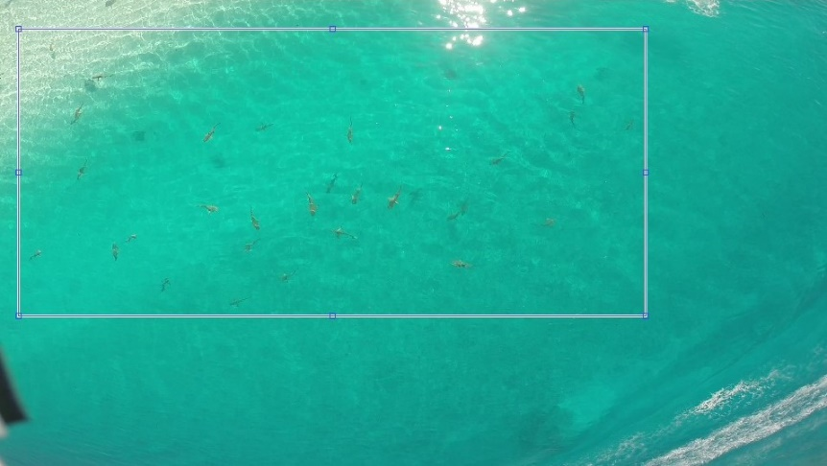

Figure 1. Sample aerial image. The highlighted rectangle shows the area of interest selected by the user to apply the labeling process.

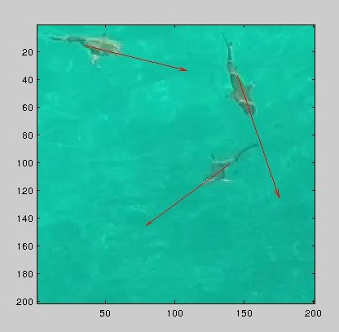

Figure 2. Sample of labeling windows containing sharks.

* 1. *Post-processing analysis*

In order to quantify the distance between individuals, the nearest neighbour to each labeled shark was determined using the central position (Cx,Cy) as reference. For each shark’s central position, our algorithm calculated the Euclidean distance towards all labeled sharks and only kept index of the individual identity that minimized this distance. Once all nearest neighbors were determined, our algorithm calculated the level of alignment between an individual and its closest neighbour using their swimming orientation (*u,v*) and the magnitude of the vectors for comparison. Based on these values, swimming alignment was calculated using the Dot Product,

$a∙b = \left|a\right|× \left|b\right|× cos(θ)$,

where $a$ and $b$ are the vectors defining the swimming orientation of two neighbour sharks, $\left|a\right|$ and $\left|b\right|$ represent the magnitudes (i.e., lengths in pixels) of the vectors and $θ$ is the angle (in degrees) between $a$ and $b$.

Values of each individual shark (e.g., the distance to its nearest companion, alignment level) were compared to median estimates for the shoals sighted in a sampled image. We assumed that an individual shark was swimming in a coordinated manner with its nearest neighbour, i.e., schooling *sensus* Pitcher and Parrish (1993) and Rieucau et al. (2015), if the relative distance between them was smaller than 2 relative body length, $Bl$ (in pixels). This criterion (threshold) was based on the median of the set of body lengths, *Ls*, of all individuals measured on a given sampled aerial image, and calculated as follow,

$Ls = \bigcup_{i=1}^{n}{\sqrt{({{Tx}_{i}-{Hx}_{i})}^{2}+({{Ty}_{i}-{Hy}_{i})}^{2}}}$,

where n is the number of labeled sharks. Next, the median $\tilde{Bl}$, was calculated as the ${\left\{\left(n + 1\right) ÷2\right\}}^{th}$ value of the sorted series, *Ls*. The conservative threshold, $τ$, was established from this value as being 2 times $\tilde{Bl}$,

$τ = 2×\tilde{Bl}$.

Distances between 2 closest individuals smaller than the established threshold ( $τ)$ were outputted as red colored asterisks on the image (Figure 3), where an asterisk represented the central position (Cx,Cy) of each shark labelled on a sampled frame. Blue asterisks indicated between-individuals distances greater that $τ$.

The median angle between all pairs of sharks, $\tilde{θ}$, present in a frame was used as a threshold to assess how well sharks were aligned with their closest neighbour. Cases where $θ$ < $\tilde{θ}$ between 2 closest individual sharks were outputted as red colored arrows (each arrow indicating the swimming direction of each individual). Conversely, cases where $θ$ > $\tilde{θ}$ were represented by blue arrows, suggesting that the two closest sharks were swimming in a less well aligned fashion.

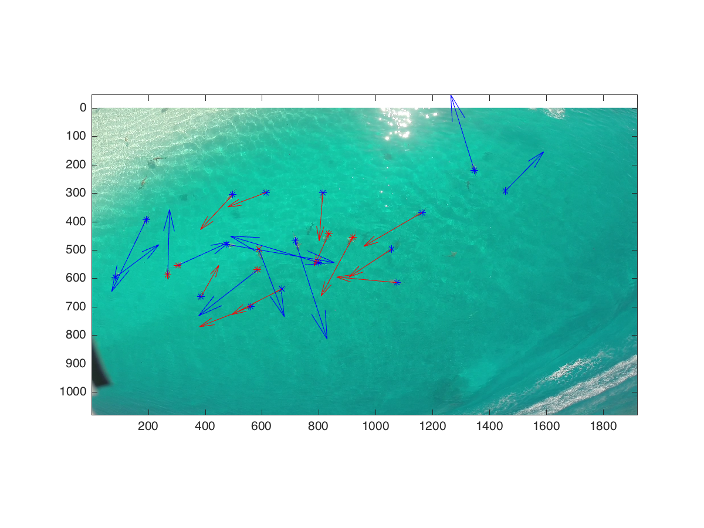

Figure 3.